Virtual Testing Video Recording and Upload Instructions

PLEASE READ THIS DOCUMENT BEFORE FILMING AND UPLOADING FOR BEST RESULTS

Shooting Location/Style
- Videographer should stand at center ice, higher up than the boards to capture all corners of the rink. Stand in a location to reduce obstructions as much as possible.
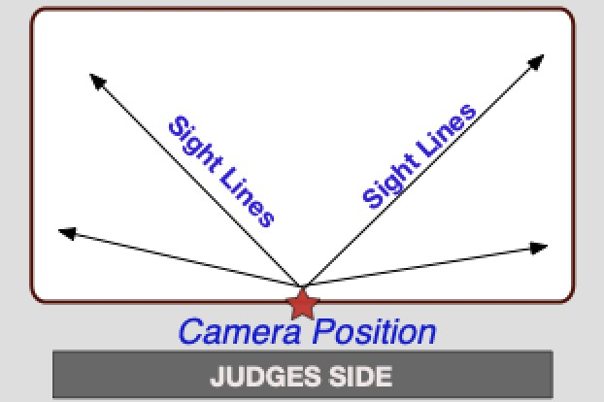
- Zoom in enough to have the skater fill a good amount of the screen but remain in focus. IMPORTANT: Keep the skater head to toe in the center of the screen (i.e. the frame) when following them during their performance.
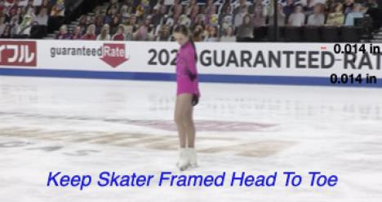

Camera/Phone Specs/Setup
- Professional video cameras or cell phones with high-definition recording capability are acceptable.
  - If using a phone or tablet, film in landscape mode (turn the phone horizontally for a wide view).
- Videos are preferred to be shot in 1080p60 but must be a minimum of 720p60. Videos less than 720p will not be accepted for review.
  - To adjust video settings on an iPhone, go to Settings/Camera/Record Video
  - To adjust video settings on an Android Phone, go to Camera Apps/Settings Options Icon (Gear Icon)/Video Size
- Switch to Airplane Mode
- Make sure there is enough space available on your phone to record. We recommend at least 2GB of available space.
- Clean your camera lens before you start recording

Recording Instructions
- If available, mount your phone on a tripod or steady mount. If handheld, the videographer should follow the athlete as smoothly as possible.
- Include a time stamp at the beginning of the final video. Hold up a phone in front of the camera that shows the date and time.
- Announce the skater and test being performed or hold up a copy of the test paper prior to the start of the test.
- Record a test video, preferably a full run thru of the performance to get comfortable with the flow of the program. Watch it back and see how the recording looks and make adjustments accordingly for the final video.
- Do your best to make sure the music is loud enough for the officials to hear when they replay the videos during the judging process. We recommend you turn up the music when you record the program being skated on the ice. Moves in the field tests should not have any music playing during the test.
- IMPORTANT: Keep frame clear of other skaters and make sure there is no other background music or noise (Ex. other coaches speaking to students at boards).

Video Upload Instructions
Deadline: We encourage you to complete your video and upload as soon as possible after you register. With the possibility of rink closures around the country it is important to not wait until the last possible date to record and video your performance.

REMINDER: Videos may only be uploaded one time and must be uploaded no later than March 31, 2021.

File Name: All files MUST be renamed to reflect the skater/team name, level and discipline. Each video should be titled with Skater First and Last Name, Level Event.

Example | Label (should match registration signup)
Solo Pattern Dance | Suzy Skater_Silver Solo Dance_Tango
Solo Pattern Dance – Adult | Suzy Skater_Silver Solo Dance_Tango_Adult21  Suzy Skater_Silver Solo Dance_Tango_Adult50
Partnered Pattern Dance – Standard | Suzy Skater_Silver Partnered Dance_Tango
Partnered Pattern Dance – Adult | Suzy Skater_Silver Partnered Dance_Tango_Adult21  Suzy Skater_Silver Partnered Dance_Tango_Adult50
Partnered Pattern Dance – Standard (Pandemic Partner) | Suzy Skater_Silver Partnered Dance_Tango_PANDEMIC PARTNER
Partnered Pattern Dance – Adult (Pandemic Partner) | Suzy Skater_Silver Partnered Dance_Tango_Adult21_PANDEMIC PARTNER  Suzy Skater_Silver Partnered Dance_Tango_Adult50_PANDEMIC PARTNER
Free Skate – Standard  Free Skate – Adult | Suzy Skater_Novice_Freeskate  Suzy Skater_Adult Gold_Freeskate_Adult21  Suzy Skater_Adult Gold_Freeskate_Adult50
Free Skate – Pairs | Cain-LeDuc_Senior Pairs_Freeskate
Free Dance – Standard  Free Dance – Solo – Standard  Free Dance – Solo – Adult | Davis-White_Senior_Free Dance  Suzy Skater_Solo Senior_Free Dance  Suzy Skater_Solo Senior_Free Dance_Adult21  Suzy Skater_Solo Senior_Free Dance_Adult50

Verification: The final submission by the athlete MUST be verified using the affidavit to be one continuous video and not edited to any extent. Video submissions will not contain any editing, splicing and must be recorded from one angle. Any videos that are deemed edited will be automatically revoked and refunds will not be issued.
Confirmation: After you upload your video per the links below, please send a confirmation email to the Test Chair, Kathleen Ogren at jkckogren@gmail.com and CC: your coach.

Upload Location
Videos should be uploaded to the skater’s video sharing platform of choice (Google Drive, Dropbox, Box, One Drive, etc.). Skaters will provide a link to the video when submitting their registration; video sharing settings should be set to allow anyone with the link to view and download.

Once all videos are received, the Test Chair will upload the videos to the Club’s sharing platform (Google Drive, Dropbox, Box, One Drive). There should be a separate folder for each test. The folders will need to be shared with all officials.

